

**Functional Requirement Specification for Incident Management**

| Author: | Sean Musgrave, Phillip Caruthers, Chris Rodrigues, Joseph Ledesma, Kpumbu Jaidzeka |
| --- | --- |
| Approved By: | Prakash Agrawal |
| Version: | v.1 |
| Today’s Date: | December 9, 2021 |
| Approved (Yes/No) | No |

**1.0 Introduction** **2**

1.1 Background 2

1.2 Purpose 3

1.3 Scope 3

**2.0 Functionality Requirement** **4**

2.1 Form Design for different States 4

2.1.1 Form Design (New) 4

2.1.2 Form Design (In Progress) 5

2.1.3 Form Design (On Hold) 5

2.1.4 Form Design (Resolved) 5

2.1.5 Form Design (Closed) 6

2.1.6 Form Design (Canceled) 6

2.2 Creating a New Incident 6

2.2.1 State Descriptions 7

2.3 Incident Update/Close and Functionality 7

**2.4 Priority, Impact, and Urgency** **8**

2.5 Parent Incident Task Generation 9

2.6 Auto-Problem Generation 9

2.7 Assignment Rule 10

2.8 Contextual Search 12

2.9 Applications and Modules 13

**3.0 Form Fields** **14**

3.1 New Incident Form Fields selected 14

3.1.1 Out of the Box Form Fields selected 14

3.1.2 Workspace View Changes by state 18

3.1.3 Default View Changes by state 20

3.1.4 Self-Service View Changes by state 22

3.2 Update Incident Form Fields available 25

3.2.1 Out of the box Form Fields available 25

3.2.2 Planned Form Fields available 26

**3.3 Incident Task Form Fields** **28**

3.4 UI Actions 29

3.3.1 Out of the box UI Actions 29

3.3.2 Planned Changes 31

3.4 UI Policies 32

3.4.1 Out of the box UI Policies 32

3.4.2 Planned Changes 34

**4.0 Notifications** **34**

4.1 Configure Notification Properties 34

4.2 OOB Notifications 35

4.2 New Incident Created Notification 36

4.2.1 - Notification Properties 36

4.2.2 Configure Receiver And Content 38

4.2.3 The Email Template Must Look as shown below. 40

4.3 Incident State Change Notification (On Hold State) 41

4.3.1 - Notification Properties 41

4.3.2 Configure Receiver And Content 41

4.3.3 The Email Template Must Look as shown below: 42

4.4.1 - Notification Properties 43

4.4.2 Configure Receiver And Content 44

4.4.3 The Email Template 45

4.5 Incident State Change Notification (Closed) 46

4.5.1 - Notification Properties 46

4.5.2 Configure Receiver And Content 47

4.6 General Incident Update 48

4.6.1 - Notification Properties 48

4.6.2 Configure Receiver And Content 49

4.7 Priority One Notification (To Response Team) 49

4.7.1 - Notification Properties 49

4.7.2 Configure Receiver And Content 50

4.8 SLA Breach Notification (To Manager) 51

4.8.1 - Notification Properties 51

4.8.2 Configure Receiver And Content **51**

**5.0 Conclusion** **52**

## 

## 1.0 Introduction

### 1.1 Background

Incident reporting is essential to business operations. Incidents are defined as any disruption to a service, this could range from something simple to something which needs to be taken care of ASAP such as a group of users not being able to log in to a service. While we could utilize the out of the box Incident application to address these issues, it isn’t something that’s efficient or effective and so our goal is to replace this layout for something far more streamlined to present to a potential customer.

Instance - <https://dev105680.service-now.com/>

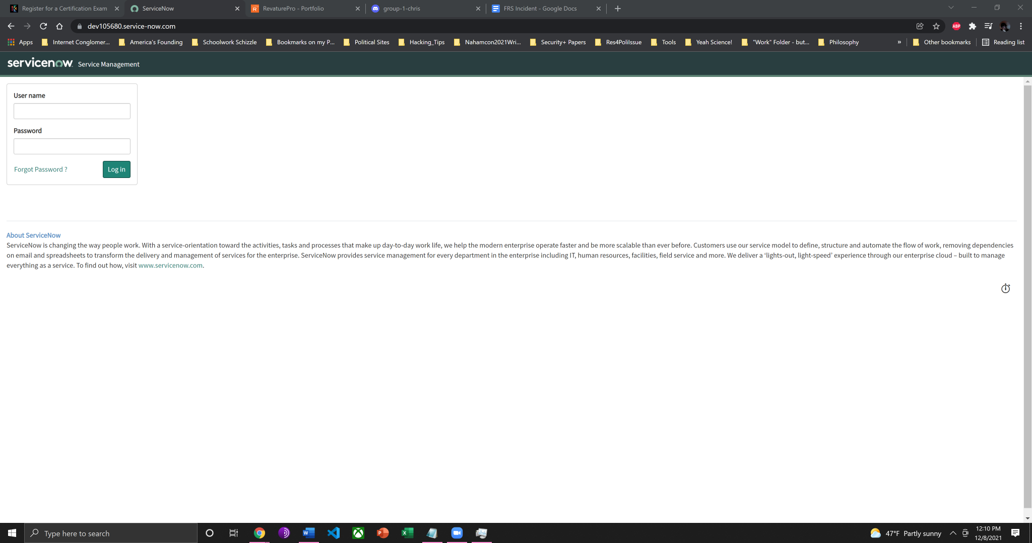

### 1.2 Purpose

This Functional Requirements Specification will develop a process to set up the Incident Application. The process defined here will help new customers quickly build and deploy the Incident Application.

### 1.3 Scope

The following items have been edited from the ServiceNow OOB configuration:

State and configuration of Incident and Incident Task Form.

Notifications related to incidents.

## 2.0 Functionality Requirement

### 2.1 Form Design for different States

Different states on the Incident form will prompt change in the layout of the form. For example, once an Incident has been saved and changed to On Hold, a drop down menu (On Hold Reason) will be displayed. For this section, we will include pictures of the fields that are made mandatory due to state changes, and for Closed and Canceled we will show the form after the form has been saved because the same fields that are made mandatory for them have already been shown in other states.

#### 2.1.1 Form Design (New-Default View)

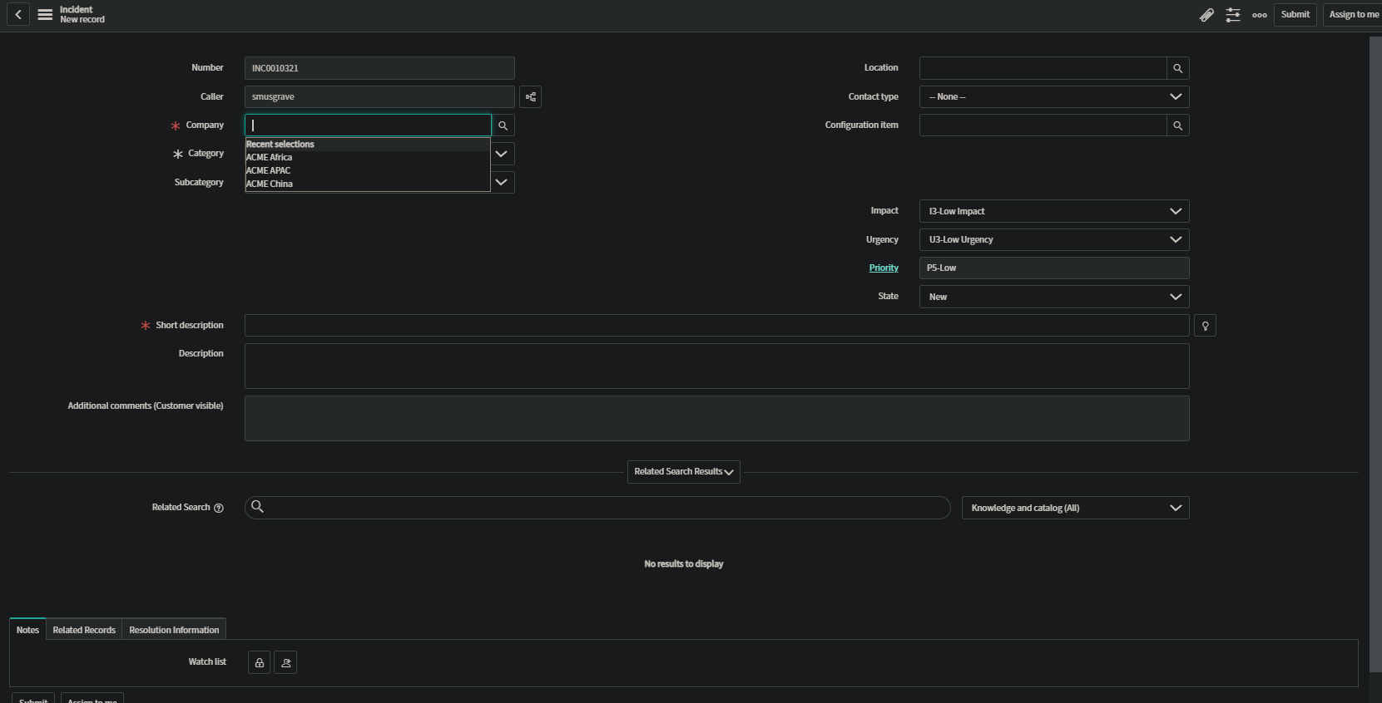

#### 2.1.2 Form Design (In Progress-Default View)

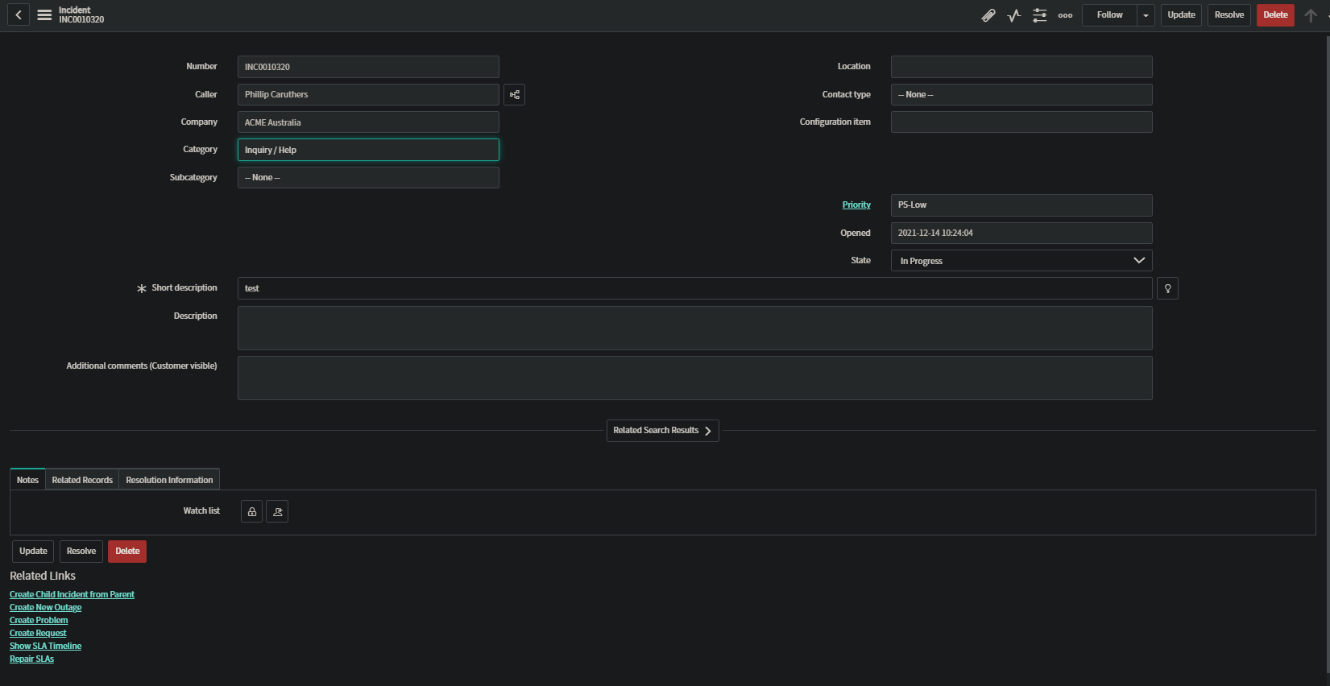

#### 2.1.3 Form Design (On Hold-Default View)

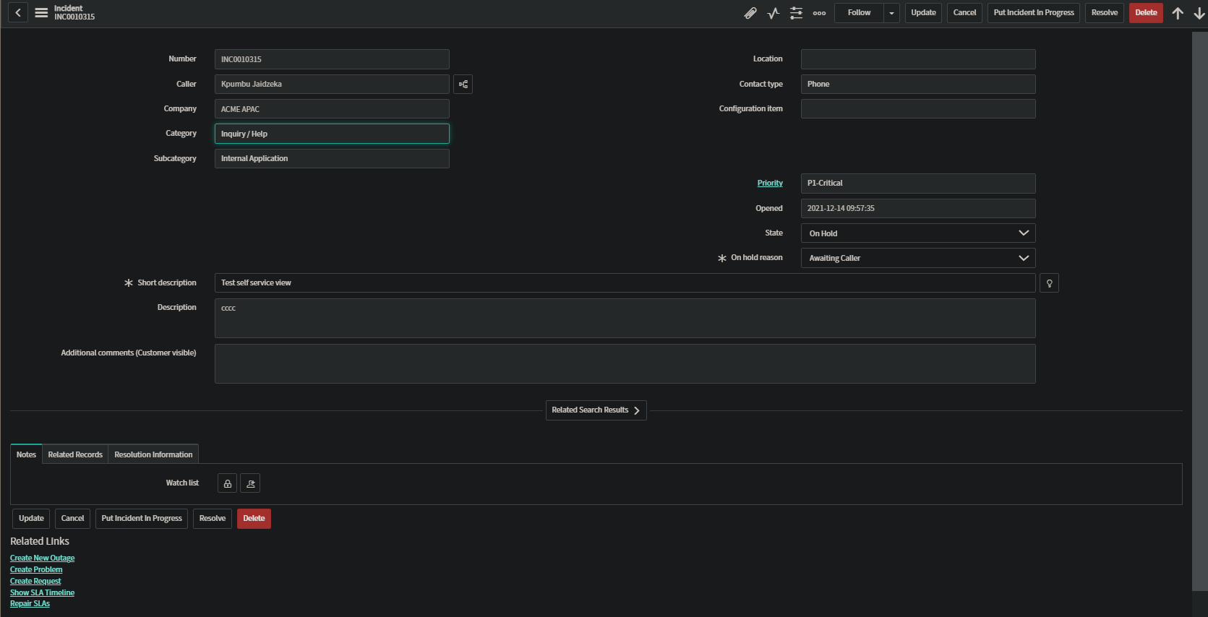

#### 2.1.4 Form Design (Resolved-Default View)

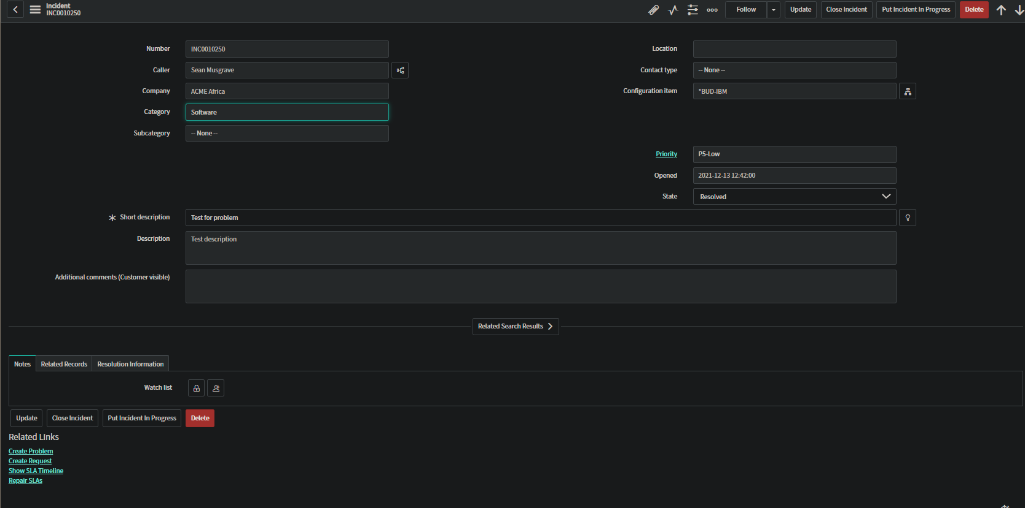

#### 2.1.5 Form Design (Closed/Canceled-Default View)

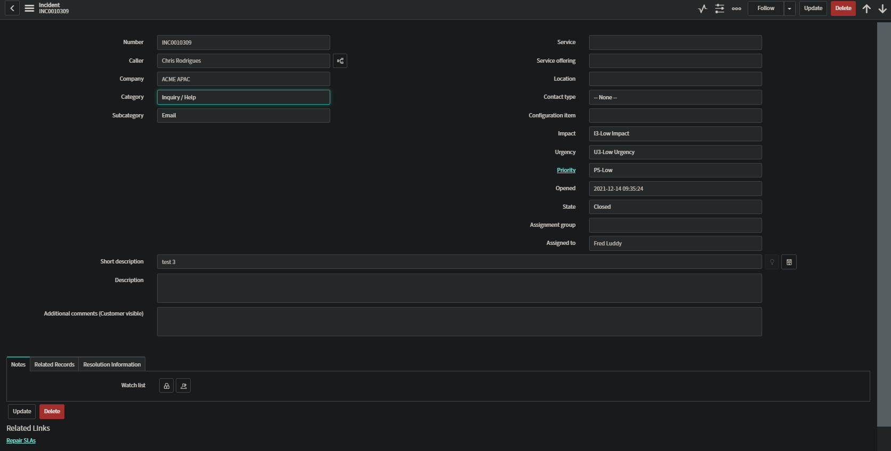

### 2.2 Creating a New Incident

### 2.2.1 State Descriptions

| State | Description |
| --- | --- |
| New | Incident is logged but not yet investigated. |
| On Hold | The responsibility for the incident shifts temporarily to another entity to provide further information, evidence, or a resolution. When you select the On Hold option, the On hold reason list appears containing the substates. |
| In Progress | Incident is assigned and is being investigated. |
| Resolved | A satisfactory fix is provided for the incident to ensure that it does not occur again. |
| Closed | Incident is marked Closed after it is in the Resolved state for a specific duration and it is confirmed that the incident is satisfactorily resolved. |
| Canceled | Incident was triaged but found to be a duplicate incident, an unnecessary incident, or not an incident at all. |

| **Substates for On Hold** | | | | |
| --- | --- | --- | --- | --- |
| **On hold reason** | Awaiting Caller | Awaiting Problem | Awaiting Change | Awaiting Vendor |
| **Remarks** |  | When chosen will auto generate a problem as shown in section 2.6. |  |  |

### 2.3 Incident State Matrix

Out of the box, Incidents can be updated to all states, regardless of what state they are currently in, except for Closed and Canceled. Closed and Canceled Incidents are immediately removed from the Open Incidents module and put in the All Incidents module. Our solution is to set the values of the form logically once a certain state has been updated, and thereby change the layout of the form.

| **State** | **To New** | **To In Progress** | **To On Hold** | **To Resolved** | **To Closed** | **To Canceled** |
| --- | --- | --- | --- | --- | --- | --- |
| **From New** |  | ✔ |  |  |  |  |
| **From In Progress** |  |  | ✔ | ✔ |  |  |
| **From On Hold** |  | ✔ |  | ✔ |  | ✔ |
| **From Resolved** |  | ✔ |  |  | ✔ |  |
| **From Closed** |  |  |  |  |  |  |
| **From Canceled** |  |  |  |  |  |  |
| Checkmark indicates whether the user can go to these states | | | | | | |

### 

### 2.4 Priority, Impact, and Urgency

The default Priority based on the Urgency and Impact is listed in the table below.

| Default Priority based on Impact and Urgency | | | |
| --- | --- | --- | --- |
| Impact/Urgency | **1-High** | **2-Medium** | **3-Low** |
| **1-High** | 1-Critical | 2-High | 3-Moderate |
| **2-Medium** | 2-High | 3-Moderate | 4-Low |
| **3-Low** | 3-Moderate | 4-Low | 5-Planning |

The labels for Impact and Urgency and Priority using a dictionary override so the changes only affect the fields on the incident table. These will be changed to what is listed on the table below.

| Changed Priority, Impact, and Urgency Labels for Incident and Incident Task | | | |
| --- | --- | --- | --- |
| Impact\Urgency | **U1-High Urgency** | **U2-Medium Urgency** | **U3-Low Urgency** |
| **I1-High Impact** | P1-Critical | P2-Important | P3-Moderate |
| **I2-Medium Impact** | P2-Important | P3-Moderate | P4-Minor |
| **I3-Low Impact** | P3-Moderate | P4-Minor | P5-Low |

This changes were made in the sys_choice table according to the following table.

### 2.5 P1 Incident Task Generation

Flow designer will be used to auto-generate an incident task when a P1 incident is established. An ‘Incident Task’ group will be created to be assigned the task.

| **Table** | **Trigger** | **Condition** | **Run Trigger** | **Remarks** |
| --- | --- | --- | --- | --- |
| Incident[incident] | Created or Updated | Priority is P1-Critical AND Active is true | Once | Trigger runs when first child is added creating a parent incident. |

The create action was used to create the incident task record, and copy over specific values from the trigger incident as shown.

| Create Task Action on Incident Task[incident_task] table | | |
| --- | --- | --- |
| **Field Values** | **Source** | **Remarks** |
| Short Description | Trigger>Incident Record>Short Description |  |
| Incident | Trigger>Incident Record |  |
| Description | Trigger>Incident Record>Description |  |
| Assignment group | Parent Incident Tasks | Assignment group |
| Work Notes | Trigger>incident Record> Work notes |  |
| Priority | Trigger>Incident Record>Priority |  |
| Configuration Item | Trigger>Incident Record>Configuration Item |  |
| State | Open | Set to open automatically since group is assigned. |

### 2.6 Auto-Problem Generation

Flow designer will be used to automate the task of creating a problem task record when an incident is awaiting a problem. The trigger will be set to run on the Incident table when Updated. Conditions will be set to State is On Hold and On Hold Reason is Awaiting Problem.

| **Table** | **Trigger** | **Condition** | **Run Trigger** | **Remarks** |
| --- | --- | --- | --- | --- |
| Incident[incident] | Updated | State is On Hold AND On hol reason is Awaiting Problem AND Active is true | Once |  |

| Create Record on Problem[problem] table | | |
| --- | --- | --- |
| **Field Values** | **Source** | **Remarks** |
| Problem Subject | Trigger>Incident Record>Short Description |  |
| Incident | Trigger>Incident Record |  |
| Category | Other |  |
| Assignment group | Incident Related Problems | Assignment group. Manager must be set to accommodate problem teams' auto assignment rules. |
| Problem Details | Trigger>incident Record> Number AND Trigger>incident Record> Description |  |
| Reported By | Trigger>Incident Record>Caller |  |
| CI | Trigger>Incident Record>Configuration Item |  |
| Subcategory | Other |  |

### 2.7 Assignment Rule

The categories and subcategories used will follow the table below.

| **Category** | **Subcategories** |
| --- | --- |
| Inquiry/Help | Antivirus,Email,Internal Application, Other |
| Software | OS, Email, Applications, Other |
| Hardware | PC, Keyboard, Mouse, Monitor, Printer, Other |
| Network | Router, Wireless, LAN, VPN, DNS, Other |
| Database | SQL, Oracle |
| Human Resources | Paperwork, Complaints, General Assistance |
| Administrative | Finance, Billing, Administrative Applications, Scheduling Issues, Other |

Assignment rules will be used to auto assign groups to an incident based on certain conditions. Category and subcategory will be used to determine the correct group to assign the incident to. Priority 1 records will be automatically assigned a special P1 group that specializes in dealing with urgent tickets. Assignment group will follow the tables below.

| Groups to be added | | |
| --- | --- | --- |
| Name | Description | Remarks |
| Help Desk Incidents | Handle Inquiry/Other | Managers must be set for all groups to accommodate problem teams auto assignment rules. |
| IT Incidents | Hardware/Software incidents |  |
| Network Incidents | Network Incidents |  |
| Database Incidents | Database Incidents |  |
| HR Incidents | Human Resources Incidents |  |
| Administrative Incidents | General Office Incidents |  |
| P1 Incidents | P1 Incidents |  |
| Parent Incident Task | Assigned Auto-generated Incident Tasks |  |
| Incident Related Problem | Assigned Auto-generated Problems from Incidents |  |

| **Category** | **Assignment Group** |
| --- | --- |
| Inquiry/Help | Help Desk Incidents |
| Software | IT Incidents |
| Hardware | IT Incidents |
| Network | Network Incidents |
| Database | Database Incidents |
| Human Resources | HR Incidents |
| Administrative | Administrative Incidents |

Priority 1 tickets will be assigned to the P1-team group. Each assignment rule will need to account for this by including a condition to ensure it is not priority one. The assignment rules to be created as shown in the table below.

| **Name** | **Table** | **Conditions** | **Assign To Group** |
| --- | --- | --- | --- |
| Inquiry/Help Incident | Incident[incident] | Priority is not 1-Critical AND Category is Inquiry/Help | Help Desk Incidents |
| Software Incident | Incident[incident] | Priority is not 1-Critical AND Category is Software | IT Incidents |
| Hardware Incident | Incident[incident] | Priority is not 1-Critical AND Category is Hardware | IT Incidents |
| Network Incident | Incident[incident] | Priority is not 1-Critical AND Category is Network | Network Incidents |
| Database Incident | Incident[incident] | Priority is not 1-Critical AND Category is Database | Database Incidents |
| Human Resources Incident | Incident[incident] | Priority is not 1-Critical AND Category is Human Resources | HR Incidents |
| Administrative Incident | Incident[incident] | Priority is not 1-Critical AND Category is Administrative | Administrative Incidents |
| Priority 1 Incident | Incident[incident] | Priority is 1-Critical | Priority 1 Incidents |

### 2.8 Contextual Search

The related search field is available by default in the self-service and default views. The search uses the entered short description to display results. Search Resources will be included as shown below.

| **View** | **Search Fields** | **Search Resources** | **Remarks** |
| --- | --- | --- | --- |
| Self Service/Default When Creating Incident | Short description | Knowledge and catalog, Outages, Open Outages, Open Incidents, Resolved Incidents | Limited view pertinent to a self-service or basic user. Goal to deter incident creation if possible. |

### 2.9 Applications and Modules

Three separate applications, containing different module configurations will be created. Access by role will match the roles given to the different views.

| **View** | **Application** | **Modules** | **Remarks** |
| --- | --- | --- | --- |
| Self Service | Self-service Incident | Create New Incident, Watched Incidents, Request Password Change | No role required. |
| Default | Employee Incidents | Create Incident, Open, Resolved, Closed Incidents | Must have role  standard_employee |
| Workspace | Incident Workspace | Assigned to me, Open, Open - in “New” state, Open - Unassigned, Resolved, All, Overview, Critical Incidents Map | Must have ITIL role. |

### 2.10 Related Lists

Related lists will only be available in the Workspace view, since they will only be relevant to people working on resolving the incidents. Related Lists by default will follow the table below.

| **Related Lists(Workspace View Only)** | |
| --- | --- |
| **Name** | **View** |
| Task SLAs | Workspace |
| Affected CIs | Workspace |
| Child Incidents | Workspace |
| Incidents By Same Caller | Workspace |
| Incident Tasks | Workspace |

## 

## 3.0 Form Fields

There are several views for different context users. Of the views available we will be defining three views in particular:

* Workspace
* Default
* Self-Service

Between these three views they will have their views restricted as per their roles in or out of the organization. Workspace users will be ITIL or Incident Management specialists who work with and resolve incidents. Default users will be organizational users who use submit tickets to be worked on by the Incident Management team. Self-Service users will be non-organizational users who submit tickets to the organization regarding outages of services.

### 3.1 New Incident Form Fields selected

#### 3.1.1 Out of the Box Form Fields selected

The Out of the Box Workspace view is very basic and forces you to fill everything in manually. Users at a company would not want to do this, so several fields should be auto populated out of the box for each company. Fields such as the company name, username, dependent on the case the caller will be auto populated.

| Workspace View | | | | |
| --- | --- | --- | --- | --- |
| **Field Name** | **Mandatory** | **Visible** | **Read Only** | **Clear value** |
| number | false | true | false | false |
| company | true | true | false | false |
| caller | true | true | false | false |
| Subscriber’s list | false | false | false | false |
| location | false | true | false | false |
| category | false | true | false | false |
| subcategory | false | true | false | false |
| service | false | true | false | false |
| Service offering | false | true | false | false |
| Configuration item | false | true | false | false |
| Short description | true | true | false | false |
| description | true | true | false | false |
| opened | false | false | false | false |
| closed | false | false | false | false |
| Contact type | false | true | false | false |
| state | false | true | false | false |
| On-hold reason | true | false | false | false |
| impact | false | true | false | false |
| urgency | false | true | false | false |
| priority | false | true | true | false |
| Assignment group | false | true | false | false |
| Assigned to | false | true | false | false |
| Resolution info | false | true | false | false |
| Related records | false | true | false | false |
| notes | false | true | false | false |
| Additional notes | false | false | false | false |

The Out of the Box Default view again is very base and shares a lot of overlap with the Workspace view. This should not be the case as Default users, while organizations should absolutely be able to see these items, but they should not be able to edit or change them. Here is where most changes need to come to ensure fields are properly auto populated and read only, or contextually auto filled per user and company.

| Default View | | | | |
| --- | --- | --- | --- | --- |
| **Field Name** | **Mandatory** | **Visible** | **Read Only** | **Clear value** |
| number | false | true | false | false |
| Company | true | true | false | false |
| caller | true | true | false | false |
| Subscriber List | false | false | false | false |
| location | false | true | false | false |
| category | false | true | false | false |
| subcategory | false | true | false | false |
| service | false | false | false | false |
| Service offering | false | false | false | false |
| Configuration item | false | true | false | false |
| Short description | true | true | false | false |
| description | true | true | false | false |
| opened | false | false | false | false |
| closed | false | false | false | false |
| Contact type | false | true | false | false |
| state | false | true | false | false |
| On-hold reason | false | false | false | false |
| impact | false | true | false | false |
| urgency | false | true | false | false |
| priority | false | true | true | false |
| Assignment group | false | true | false | false |
| Assigned to | false | true | false | false |
| Resolution info | false | true | false | false |
| Related records | false | true | false | false |
| notes | false | true | false | false |
| Additional notes | false | false | false | false |

Self Service view is for non-organizational users, so it makes sense that their view would be extremely limited. Several fields shouldn’t be editable by non-Incident Management personnel, let alone non-organizational users. Certain items should be auto populated based on who the ticket is being submitted to.

| Self-Service View | | | | |
| --- | --- | --- | --- | --- |
| **Field Name** | **Mandatory** | **Visible** | **Read Only** | **Clear value** |
| number | false | true | false | false |
| caller | true | true | false | false |
| company | false | false | false | false |
| Subscriber List | false | true | false | false |
| location | false | false | false | false |
| category | false | false | false | false |
| subcategory | false | false | false | false |
| service | false | false | false | false |
| Service offering | false | false | false | false |
| Configuration item | false | false | false | false |
| Short description | true | true | false | false |
| description | false | false | false | false |
| opened | false | true | false | false |
| closed | false | true | false | false |
| Contact type | false | false | false | false |
| state | false | true | false | false |
| On-hold reason | false | false | false | false |
| impact | false | false | false | false |
| urgency | false | true | false | false |
| priority | false | false | false | false |
| Assignment group | false | false | false | false |
| Assigned to | false | false | false | false |
| Resolution info | false | false | false | false |
| Related records | false | false | false | false |
| notes | false | false | false | false |
| Additional comments | false | true | false | false |

#### 3.1.2 Workspace View Changes by state

In a state of New, a Workspace user will need to assign a group and individual to the incident, and build out the short description if one isn’t available. Some fields will already be populated as they are either auto-generated or auto-populated based on who has submitted the incident ticket. From these changes in the incident form the state can progress to In Progress.

| State is New | | | |
| --- | --- | --- | --- |
| **Field Name** | **Mandatory** | **Visible** | **Read Only** |
| number | false | true | true |
| caller | false | true | true |
| company | false | false | false |
| location | false | true | true |
| category | true | true | false |
| subcategory | true | true | false |
| short description | true | true | false |
| description | false | true | false |
| configuration Item | false | true | false |
| contact type | true | true | false |
| state | false | true | false |
| impact | false | true | false |
| urgency | false | true | false |
| priority | false | true | true |
| assignment group | false | true | true |
| assigned to | false | true | true |
| service | false | false | false |
| service offering | false | false | false |

When the state changes to In Progress, someone has been assigned to work on the incident and address the caller’s concerns. The category and subcategory should be filled out and the service and service offering that are affected should also be filled out to define what the issue affects and what it entails. From here, the state can progress to On Hold if a response from either a vendor or caller are required, or if a change needs to be implemented, or if a problem needs to be created to progress the incident state.

| State is In Progress | | | |
| --- | --- | --- | --- |
| **Field Name** | **Mandatory** | **Visible** | **Read Only** |
| company | false | false | false |
| location | false | true | true |
| category | false | true | true |
| subcategory | false | true | true |
| service | false | false | false |
| service offering | false | false | false |
| configuration Item | false | true | false |
| contact Type | false | true | true |
| state | false | true | false |
| impact | false | true | false |
| urgency | false | true | false |
| priority | false | true | true |
| assignment group | false | true | true |
| assigned to | true | true | false |

In the state of On Hold, the Incident Management team is waiting for a response or for another task relevant to the incident to conclude because it either pertains directly to the incident or affects the incident in some way. Once the task is completed or the response is received, the state will either return to In Progress, or progress to Resolved dependent upon whether the previous task or response results in a resolution to the incident.

| State is On Hold | | | |
| --- | --- | --- | --- |
| **Field Name** | **Mandatory** | **Visible** | **Read Only** |
| on hold reason | true | true | false |
| additional comments | true | true | false |
| contact type | false | true | true |
| service | false | false | false |
| service offering | false | false | false |
| category | false | true | true |
| subcategory | false | true | true |
| location | false | true | true |
| company | false | false | false |
| short description | false | true | false |

When the state is Resolved this means the problem causing the incident has been fixed or an inquiry has been served. A time following the resolution of the incident the incident itself is kept in the resolved state until no further response is received from the end user who submitted the ticket stating that there are additional issues, or the issue has not been fully resolved. Once the time has expired without further response from the end user the ticket will enter a Closed state.

| State is Resolved | | | |
| --- | --- | --- | --- |
| **Field Name** | **Mandatory** | **Visible** | **Read Only** |
| additional comments | true | true | false |
| resolution code | true | true | false |
| resolution notes | true | true | false |
| resolved by | false | true | true |
| resolved | false | true | true |
| impact | false | true | true |
| urgency | false | true | true |
| assigned to | false | true | true |

In a Closed state, the ticket is considered completed and the end user is back up and running based on inquiry or issue resolution. Everything will be read-only upon closure of an incident ticket, to include the ability to edit, update, or add anything onto the incident in question.

| State is Closed | | | |
| --- | --- | --- | --- |
| **Field Name** | **Mandatory** | **Visible** | **Read Only** |
| additional comments | false | true | true |
| resolution code | false | true | true |
| resolution notes | false | true | true |
| resolved by | false | true | true |
| resolved | false | true | true |

#### 3.1.3 Default View Changes by state

For anyone viewing within the organization, having submitted a ticket, there are certain fields they shouldn’t need to fill out and others they shouldn’t be able to fill out. The changes made to the Out of the Box defaults are such that these users will not be able to change information in an Incident that should not be changed and be required to fill out items that should be filled out.

| State is New | | | |
| --- | --- | --- | --- |
| **Field Name** | **Mandatory** | **Visible** | **Read Only** |
| number | false | true | true |
| caller | false | true | true |
| company | false | false | false |
| location | false | true | true |
| category | true | true | false |
| subcategory | false | true | false |
| configuration item | false | true | false |
| short description | true | true | false |
| description | false | true | false |
| additional comments | false | true | false |
| service | false | false | false |
| service Offering | false | false | false |
| assignment Group | false | false | false |
| knowledge | false | false | false |
| opened at | false | false | false |
| assigned to | false | false | false |

Once the ticket is In Progress, the ticket has been assigned and the organizational user will be able to view that information but not change it except for the short description. A history exists for the short description so if it needs to be reviewed it will be available but if new details arise to update the short description can be altered.

| State is In Progress | | | |
| --- | --- | --- | --- |
| **Field Name** | **Mandatory** | **Visible** | **Read Only** |
| configuration item | false | true | false |
| category | false | true | true |
| sub-category | false | true | true |
| assignment group | false | true | true |
| assigned to | false | true | true |
| short description | true | true | false |
| service | false | false | false |
| service offering | false | false | false |
| urgency | false | false | false |
| assigned to | false | false | false |
| knowledge | false | false | false |
| assignment group | false | false | false |
| impact | false | false | false |

If the ticket is On Hold, a Default user will need to see additional information regarding the ticket to address customer concerns or the concerns of the part of the organization that submitted the ticket. What is being waited on or if the organization needs to respond to an inquiry are important so that the ticket can be updated with the necessary information if it is requested.

| State is On Hold | | | |
| --- | --- | --- | --- |
| **Field Name** | **Mandatory** | **Visible** | **Read Only** |
| state | false | true | true |
| on hold reason | false | true | true |
| additional comments | true | true | false |
| short description | true | true | false |
| service | false | false | false |
| service offering | false | false | false |
| urgency | false | false | false |
| assigned to | false | false | false |
| knowledge | false | false | false |
| assignment group | false | false | false |
| impact | false | false | false |

During the Resolved state the organization within the company that submitted the ticket will have a window to respond whether their issue was fixed or if their inquiry is complete. This way, the ticket can be moved to a Closed state, or the timer will expire, and it will go to a closed state anyway. Since Default users aren’t working on the ticket, none of the resolution information will be available for them to edit so it will all be read only, if anything further needs to be done, additional notes will be open for communication to the Incident Management Team.

| State is Resolved | | | |
| --- | --- | --- | --- |
| **Field Name** | **Mandatory** | **Visible** | **Read Only** |
| resolution code | false | true | true |
| resolution notes | false | true | true |
| resolved by | false | true | true |
| resolved | false | true | true |
| additional comments | false | true | false |
| service | false | false | false |
| service offering | false | false | false |
| urgency | false | false | false |
| assigned to | false | false | false |
| knowledge | false | false | false |
| assignment group | false | false | false |
| impact | false | false | false |

Once the ticket reaches a closed state, dependent upon company policy, additional comments would be read only or not. If company policy is to open a new ticket rather than reopen an old ticket for the same or related issue the additional comments will be closed, otherwise if the policy is to reopen tickets, the additional comments will be open.

| State is Closed | | | |
| --- | --- | --- | --- |
| **Field Name** | **Mandatory** | **Visible** | **Read Only** |
| short description | false | true | true |
| description | false | true | true |
| additional comments | false | true | true |

#### 3.1.4 Self-Service View Changes by state

For a customer, there is only a base amount of information they would understand. Their ticket would be submitted to the company they use and the company itself would submit the overall ticket to ITSM regarding the service being affected. So, it stands to reason that the customer would only have a couple of fields to fill out.

| State is New | | | | |
| --- | --- | --- | --- | --- |
| **Field Name** | **Mandatory** | **Visible** | **Read Only** | **Remarks** |
| number | false | true | true |  |
| caller | false | true | true |  |
| Subscriber List | false | true | false |  |
| category | true | true | false |  |
| subcategory | false | true | false |  |
| short description | true | true | false |  |
| description | true | true | false |  |
| state | false | true | true | Left read only as false for testing. |
| opened | false | true | true |  |
| closed | false | true | true |  |
| Additional comments | false | true | true |  |

Once the ticket has been submitted all updates will be read-only except for additional comments. Any updates from the customer can be sent through additional comments.

| State is In Progress | | | | |
| --- | --- | --- | --- | --- |
| **Field Name** | **Mandatory** | **Visible** | **Read Only** | **Remarks** |
| number | false | true | true |  |
| caller | false | true | true |  |
| Subscriber List | false | true | false |  |
| category | false | true | true |  |
| subcategory | false | true | true |  |
| short description | false | true | true |  |
| description | false | true | true |  |
| state | false | true | true | Left Read only False for testing. |
| opened | false | true | true |  |
| closed | false | true | true |  |
| Additional comments | false | true | true |  |

The customer can see the reasons for why the incident is on hold and can respond through additional comments to inquiries or see that the Incident Management Team is indeed working on the ticket and progressing towards a solution here.

| State is On Hold | | | | |
| --- | --- | --- | --- | --- |
| **Field Name** | **Mandatory** | **Visible** | **Read Only** | **Remarks** |
| number | false | true | true |  |
| caller | false | true | true |  |
| Subscriber List | false | true | false |  |
| category | false | true | true |  |
| subcategory | false | true | true |  |
| short description | false | true | true |  |
| description | false | true | true |  |
| state | false | true | true | Left Read only False for testing. |
| opened | false | true | true |  |
| closed | false | true | true |  |
| Additional comments | false | true | true |  |
| On hold reason | true | true | true | Left Read only False for testing. |

The Incident Management Team believe they have a fix so now the ticket is in a Resolved state, and now it is up to the customer who submitted the ticket to inform them whether the issue they were having was fixed or if there are still additional issues related to the submitted ticket to be taken care of.

| State is In Resolved | | | | |
| --- | --- | --- | --- | --- |
| **Field Name** | **Mandatory** | **Visible** | **Read Only** | **Remarks** |
| number | false | true | true |  |
| caller | false | true | true |  |
| Subscriber List | false | true | false |  |
| category | false | true | true |  |
| subcategory | false | true | true |  |
| short description | false | true | true |  |
| description | false | true | true |  |
| state | false | true | true | Left Read only False for testing. |
| opened | false | true | true |  |
| closed | false | true | true |  |
| Additional comments | false | true | true |  |

The customer has either accepted the solution by the Incident Management Team as acceptable or has failed to respond within the time given to bring up additional related issues or inform the team that the implemented fix has not solved their issue. Regardless, the timer has run out and the ticket is put into a Closed state.

| State is Closed/Canceled | | | |
| --- | --- | --- | --- |
| **Field Name** | **Mandatory** | **Visible** | **Read Only** |
| number | false | true | true |
| caller | false | true | true |
| company | false | true | true |
| category | false | true | true |
| subcategory | false | true | true |
| short description | false | true | true |
| description | false | true | true |
| opened | false | true | true |
| service | false | true | true |
| Service offering | false | true | true |
| location | false | true | true |
| Contact type | false | true | true |
| Configuration item | false | true | true |
| impact | false | true | true |
| urgency | false | true | true |
| priority | false | true | true |
| opened | false | true | true |
| state | false | true | true |
| Assignment group | false | true | true |
| Assigned to | false | true | true |
| additional comments | false | true | true |

### 3.2 Incident Task Form Fields

| **State is Pending/Open/Work in Progress** | | | | |
| --- | --- | --- | --- | --- |
| **Field Name** | **Mandatory** | **Visible** | **Read Only** | **Remarks** |
| Number | false | true | true | Auto Generated |
| Incident | false | true | true | Inherited from incident record |
| Configuration Item | false | true | false |  |
| State | false | true | false |  |
| Priority | false | true | true | Inherited from incident Priority |
| Assignment Group | false | true | true | Auto assigned on creation |
| Assigned to | false | true | false | Set to Mandatory for Work in Progress State only |
| Short Description | false | true | false | Inherited from parent incident, but can be edited. |
| Description | false | true | false |  |
| Work Notes List | false | true | false |  |
| Close Notes | false | false | false |  |

| **State is Closed** | | | | |
| --- | --- | --- | --- | --- |
| **Field Name** | **Mandatory** | **Visible** | **Read Only** | **Remarks** |
| Number | false | true | true | Auto Generated |
| Incident | false | true | true | Inherited from incident record |
| Configuration Item | false | true | false |  |
| State | false | true | false |  |
| Priority | false | true | true | Inherited from incident Priority |
| Assignment Group | false | true | true | Auto assigned on creation |
| Short Description | false | true | true | Inherited from parent incident, but can be edited. |
| Description | false | true | true |  |
| Work Notes List | false | true | true |  |
| Close Notes | false | false | true |  |

### 3.3 UI Actions

#### 3.3.1 Out of the box UI Actions

There are 23 OOB UI Actions available for the Incident table.

| **Name** | **Form Action** | **Description** | **Script** | **Condition** |
| --- | --- | --- | --- | --- |
| Create Request | False |  | False | True |
| [Create Child Incident](https://dev105680.service-now.com/sys_ui_action.do?sys_id=117f90e367cb3200060071bfa2415a51&sysparm_record_target=sys_ui_action&sysparm_record_row=2&sysparm_record_rows=23&sysparm_record_list=table%3E%3Dincident%5Etable%3Dincident%5EORDERBYtable) | True | Create a child incident similar to the current incident. | True | True |
| Create Change Request | False |  | True | True |
| Create Problem | True |  | True | True |
| Create Normal Change | True |  | True | True |
| Assign to me | False |  | True | NA |
| Resolve |  |  | True | True |
| Assign to me | False | Assign the incident to current user for List context menu | True | NA |
| Create Request | True |  | True | True |
| Archive Record | False |  | True | True |
| Report Knowledge Gap | False |  | False | True |
| Add | False |  | True | True |
| New | False | Many To Many for incidents | True | True |
| Copy Incident | True |  | True | True |
| On-Call Roster and Escalation details | True |  | True | True |
| Refresh Impacted Services | True |  | True | True |
| Print Preview | False |  | True | NA |
| New | False | Related list | True | True |
| Close Incident | True |  | True | True |
| New | False | Normal list for incidents | True | True |
| Reopen Incident | True |  | True | True |
| Create Emergency Change | True |  | True | True |
| Create Standard Change | True | Create a Standard Change Request | True | True |
| Assign to me | False | Assign the incident to current user | True | True |

#### 3.3.2 Planned Changes

| State | Form Buttons | Form Context Menus | Form Links | Remarks |
| --- | --- | --- | --- | --- |
| New | Submit | System Default | Show SLA Timeline, Repair SLA |  |
| In Progress | Update, Resolve, Delete | System Default | Show SLA, Repair SLA, Create Problem, Create Child Incident | Buttons only visible for Assigned To User and Assignment Group’s Manager |
| On Hold | Update, Resolve, Cancel Incident, Put Incident In Progress, Delete | System Default | Show SLA, Repair SLA, Create Problem, | Buttons only visible for Assigned To User and Assignment Group’s Manager |
| Resolved | Update, Incident, Put Incident In Progress, Close Incident, Delete | System Default | Create Problem,  Show SLA, Repair SLA, | Buttons only visible for Assigned To User and Assignment Group’s Manager |
| Closed | Update, Delete | System Default | Show SLA, Repair SLA | Buttons only visible for Assigned To User and Assignment Group’s Manager |
| Canceled | Update, Delete | System Default | Show SLA, Repair SLA | Buttons only visible for Assigned To User and Assignment Group’s Manager |

### 3.4 UI Policies

#### 3.4.1 Out of the box UI Policies

There are 7 OOB UI Policies available for the Incident table.

| **Short Description** | **Condition** | **UI Policy Actions** | | | |
| --- | --- | --- | --- | --- | --- |
| **Fields applicable** | **Mandatory** | **Visibility** | **Readonly** |
| Fields set to mandatory for all states | false | caller_id | True | Leave alone | Leave alone |
| short_description | True | Leave alone | Leave alone |
| Make the field 'Additional Comments' mandatory when the On Hold Reason is 'Awaiting Caller' | True | comment | True | Leave alone | Leave alone |
| Show Route Reason when incident is routed to universal request | True | route_reason | Leave alone | True | Leave alone |
| Priority is managed by Data Lookup - set as read-only | False | priority | Leave alone | Leave alone | True |
| Make fields read-only on close | True | state | Leave alone | Leave alone | True |
| opened_at | Leave alone | Leave alone | True |
| opened_by | Leave alone | Leave alone | True |
| closed_at | Leave alone | Leave alone | True |
| closed_by | Leave alone | Leave alone | True |
| company | Leave alone | Leave alone | True |
| caller_id | Leave alone | Leave alone | True |
| impact | Leave alone | Leave alone | True |
| urgency | Leave alone | Leave alone | True |
| location | Leave alone | Leave alone | True |
| number | Leave alone | Leave alone | True |
| cmdb_ci | Leave alone | Leave alone | True |
| category | Leave alone | Leave alone | True |
| escalation | Leave alone | Leave alone | True |
| assignment_group | Leave alone | Leave alone | True |
| assigned_to | Leave alone | Leave alone | True |
| short_description | Leave alone | Leave alone | True |
| Close noted | Leave alone | Leave alone | True |
| Close code | Leave alone | Leave alone | True |
|  |  | comments | Leave alone | Leave alone | True |
| Hide Universal Request if empty |  | universal_request | Leave alone | False | Leave alone |
| When state is On Hold the On hold reason field is visible and mandatory | True | hold_reason | True | True | Leave alone |

#### 

#### 3.4.2 Planned Changes

UI Policies will be implemented to match the fields layouts shown in section 3.1.2-3.1.4 tables.

## 4.0 Notifications

Notifications are important communication tools that keep users informed of events that concern them. We can use email notifications and SMS to send and receive communication from within the system. Notifications are triggered by system events.

The subscription based notifications feature enables users to subscribe to notifications of interest or unsubscribe from notifications that they do not want. This feature also enables administrators to send mandatory notifications that users cannot block. In order to first be able to configure our instance to be able to send and receive emails we must configure notification properties

### 4.1 Configure Notification Properties

By Default Outbound and Inbound email configurations are not enabled. In order for the Instance to be able to receive and send email these configurations need to be enabled.

| Configuration Type | True/False |
| --- | --- |
| Inbound email configurations | True |
| Outbound email configurations | True |

### 

### 4.2 OOB Notifications

A fresh ServiceNow instance by default comes with 271 various OOTB Notifications that deal with a range of aspects from monitoring Mid Servers or for Incident Management or even catalog task items. It is **Best Practice Not To Delete** any **OOB Notifications** but to rather tailor the already existing notifications to meet your needs or set active to false and recreate them.

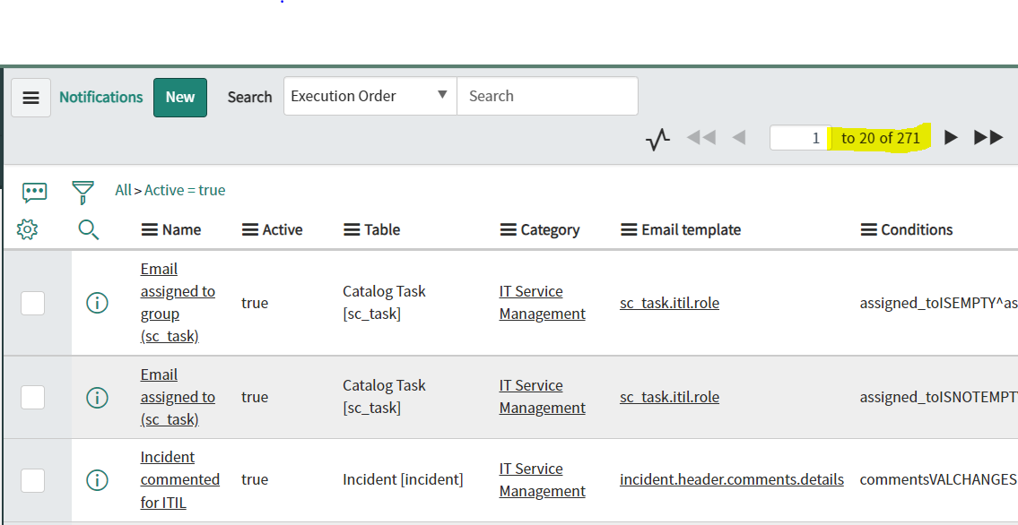

Of These Notifications only **17 Notifications** are pertaining to the **Incident** table and incident management.

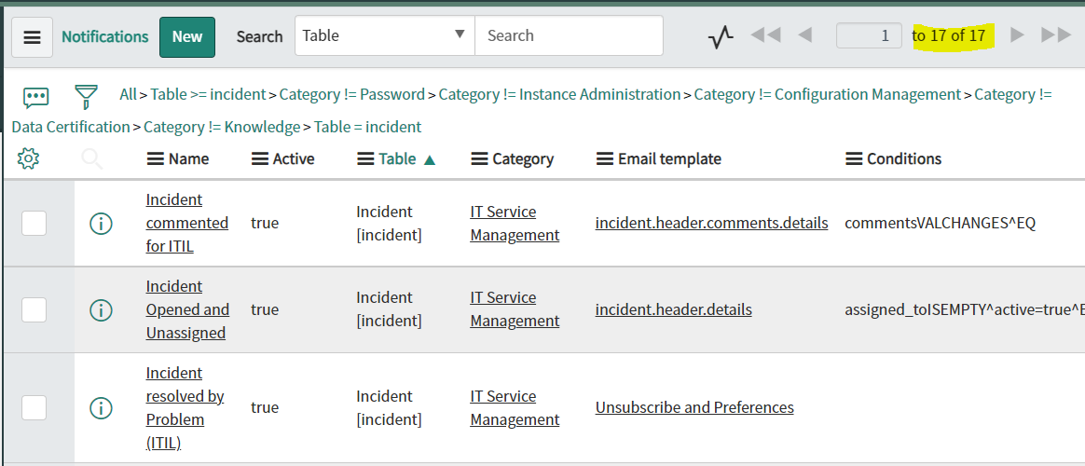

### 4.2 New Incident Created Notification

#### 4.2.1 - Notification Properties

OOTB This notification is called “incident_opened_for_me”. It has the following properties

| **Label** | **Data Type** | **Value** | **Referenced** | **Table Reference** |
| --- | --- | --- | --- | --- |
| Name | String | Incident Opened For Me | No | N/A |
| Table | Table Name | Incident | No | N/A |
| Category | Reference | Incident Communication Plan | Yes | sys_notification_category |
| Active | Checkbox | True | No | N/A |
| Send When | Dropdown | Record Inserted or Updated | No | N/A |
| Inserted | Checkbox | True | No | N/A |
| Updated | Checkbox | False | No | N/A |
| Condition | Conditional Dropdown | “Active Is True” & “Universal Request Is Empty | No | N/A |
| Advanced Conditional Script | Script Section | answer = true;  if (GlidePluginManager.isActive('com.sn_cs_sm')){  answer = new sn_cs_sm.ServiceManagementIncidentUtils().isValidCallerForIncNotif(current.caller_id.getRefRecord());  } | No | N/A |

Our customization will follow the following values:

| **Label** | **Data Type** | **Value** | **Referenced** | **Table Reference** |
| --- | --- | --- | --- | --- |
| Name | String | Incident created notification | No | N/A |
| Table | Table Name | Incident | No | N/A |
| Type | String | Email | No | N/A |
| Category | Reference | Incident Communication Plan | Yes | sys_notification_category |
| Active | Checkbox | True | No | N/A |
| Send When | Dropdown | Record Inserted or Updated | No | N/A |
| Inserted | Checkbox | True | No | N/A |
| Updated | Checkbox | False | No | N/A |
| Condition | Conditions Dropdown | Active Is True | No | N/A |
| Advanced Conditional Script | Script Section | answer = true;  if (GlidePluginManager.isActive('com.sn_cs_sm')){  answer = new sn_cs_sm.ServiceManagementIncidentUtils().isValidCallerForIncNotif(current.caller_id.getRefRecord());  } | No | N/A |

#### 4.2.2 Configure Receiver And Content

OOB This notification is configured as follows:

| **Label** | **Data Type** | **Value** | **Referenced** | **Table Reference** |
| --- | --- | --- | --- | --- |
| Users | list | Empty | Yes | sys_user |
| Groups | list | Empty | Yes | sys_groups |
| User/Groups in field | Field list | Caller | No | N/A |
| Subscribable | Checkbox | True | No | N/A |
| Send To Event Creator | Checkbox | True | No | N/A |
| Email Template | Reference | Unsubscribe and Preferences Helvetica | Yes | N/A |
| Subject | String | Incident ${task_effective_number} has been opened on your behalf | No | N/A |

We Will Customize the values as shown below:

| **Label** | **Data Type** | **Value** | **Referenced** | **Table Reference** |
| --- | --- | --- | --- | --- |
| Users | list | Empty | Yes | sys_user |
| Groups | list | Empty | Yes | sys_groups |
| User/Groups in field | Field list | Caller | No | N/A |
| Subscribable | Checkbox | True | No | N/A |
| Send To Event Creator | Checkbox | False | No | N/A |
| Email Template | Reference | Unsubscribe and Preferences Helvetica | Yes | sys_email_template |
| Subject | String | Incident ${number} Has Been Created | No | N/A |
| Importance | String | None | No | N/A |

#### 4.2.3 The Email Template.

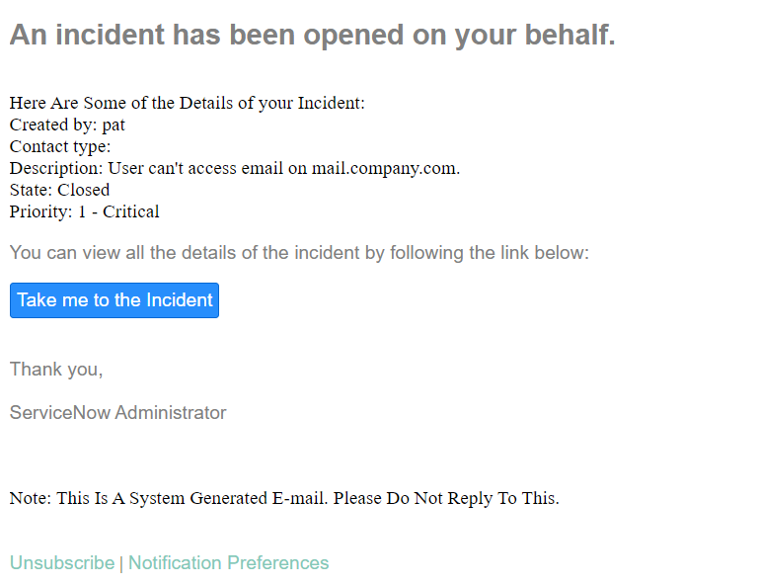

The Email Template should look similar to the example above.

To do this :

1. Delete The OOTB Email Scripts
2. Add ${mail_script:incident_has_been_opened}
3. Edit the OOB Script “ incident_has_been_opened “ to include

“Thank You, System Administrator” at the end.

1. Add the following:  
   Here Are Some of the Details of your Incident:  
   Created by: ${sys_created_by}  
   Contact type: ${contact_type}  
   Description: ${description}  
   State: ${state}  
   Priority: ${priority}
2. Add the email script ${mail_script:incident_take_me_to_the_incident}
3. Add this note at the end of the template and make it bold  
   “Note: This is a System Generated Email. Do Not Reply To This.”

### 4.3 Incident State Change Notification (On Hold State)

OOTB ServiceNow **Does Not** provide this notification. We will Configure it as shown below

#### 4.3.1 - Notification Properties

| **Label** | **Data Type** | **Value** | **Referenced** | **Table Reference** |
| --- | --- | --- | --- | --- |
| Name | String | Incident State On Hold | No | N/A |
| Table | Table Name | Incident | No | N/A |
| Category | Reference | Incident Communication Plan | Yes | sys_notification_category |
| Active | Checkbox | True | No | N/A |
| Send When | Dropdown | Record Inserted or Updated | No | N/A |
| Inserted | Checkbox | False | No | N/A |
| Updated | Checkbox | True | No | N/A |
| Condition | Conditional Dropdown | “Active Is True”  And  “State Changes To On Hold” | No | N/A |

#### 4.3.2 Configure Receiver And Content

| **Label** | **Data Type** | **Value** | **Referenced** | **Table Reference** |
| --- | --- | --- | --- | --- |
| Users | list | Empty | Yes | sys_user |
| Groups | list | Empty | Yes | sys_groups |
| User/Groups in field | Field list | Caller | No | N/A |
| Subscribable | Checkbox | True | No | N/A |
| Email Template | Reference | Unsubscribe and Preferences | Yes | sys_email_template |
| Subject | String | State Has Changed To On Hold | No | N/A |

#### 4.3.3 The Email Template

### 

The Email Template must look similar to this.  
   
To do this :

1. Copy this greeting Hi There ${caller_id},
2. Create a new Email Script called “on_hold”
3. Use the created email script “on_hold” in the template by adding ${mail_script:on_hold}
4. Specify the following

State: ${state}

On hold reason: ${hold_reason}

1. Add the Following “The reason for this may be specified in the following section: “

Work notes: ${work_notes}

Additional comments: ${comments}

1. Add the Following

Here Are Some Additonal Details of your Incident:

Created by: ${sys_created_by}

Contact type: ${contact_type}

Description: ${description}

Priority: ${priority}

1. Add this text “If the reason for the hold is still unclear and a representative does not contact you within the next 24hrs,please get in touch with a service desk.”
2. Add the Following email script and text in bold

${mail_script:incident_take_me_to_the_incident}

ServiceNow Administrator.

Note: This Is A System Generated Email. Please Do Not Reply To This.

### 4.4 Incident State Change Notification (Resolved)

#### 4.4.1 - Notification Properties

OOB This notification is called “incident_resolved”. It has the following properties

| **Label** | **Data Type** | **Value** | **Referenced** | **Table Reference** |
| --- | --- | --- | --- | --- |
| Name | String | Incident Resolved | No | N/A |
| Table | Table Name | Incident | No | N/A |
| Category | Reference | Incident Communication Plan | Yes | sys_notification_category |
| Active | Checkbox | True | No | N/A |
| Send When | Dropdown | Record Inserted or Updated | No | N/A |
| Inserted | Checkbox | False | No | N/A |
| Updated | Checkbox | True | No | N/A |
| Condition | Conditional Dropdown | “Incident state changes to resolved ” & “Universal Request Is Empty | No | N/A |
| Advanced Conditional Script | Script Textbox | answer = true;  if (GlidePluginManager.isActive('com.sn_cs_sm')){  answer = new sn_cs_sm.ServiceManagementIncidentUtils().isValidCallerForIncNotif(current.caller_id.getRefRecord());  } | No | N/A |

We shall use the same properties for this section

#### 4.4.2 Configure Receiver And Content

OOB This notification is configured as follows:

| **Label** | **Data Type** | **Value** | **Referenced** | **Table Reference** |
| --- | --- | --- | --- | --- |
| Users | list | Empty | Yes | sys_user |
| Groups | list | Empty | Yes | sys_groups |
| User/Groups in field | Field list | Caller | No | N/A |
| Subscribable | Checkbox | True | No | N/A |
| Send To Event Creator | Checkbox | True | No | N/A |
| Email Template | Reference | Unsubscribe and Preferences Helvetica | Yes | N/A |
| Subject | String | Your incident ${task_effective_number} has been resolved | No | N/A |

We Will Customize the values as shown below:

| **Label** | **Data Type** | **Value** | **Referenced** | **Table Reference** |
| --- | --- | --- | --- | --- |
| Users | list | Empty | Yes | sys_user |
| Groups | list | Empty | Yes | sys_groups |
| User/Groups in field | Field list | Caller | No | N/A |
| Subscribable | Checkbox | True | No | N/A |
| Send To Event Creator | Checkbox | False | No | N/A |
| Email Template | Reference | Unsubscribe and Preferences Helvetica | Yes | sys_email_template |
| Subject | String | Incident ${number} Has Been Resolved | No | N/A |

#### 4.4.3 The Email Template

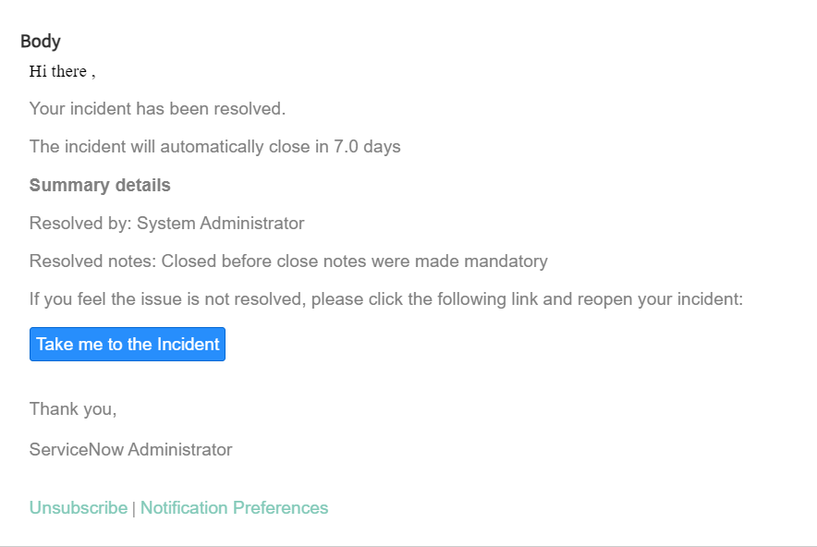

The Email Template must look similar to this.  
   
To do this :

1. Add Hi There ${caller_id} to the start of the template
2. Use the inbuilt email script incident_resolved_incident but edit it in the email scripts to add the line “We are glad to inform you,”
3. Change the font size and font to match the font used in the template.
4. Do the same for the next two scripts   
   incident_resolved_incident_details, incident_take_me_to_the_incident
5. Add these scripts to the template and add the note in bold ”Note: This Is A System Generated Email. Please Do Not Reply To This”

### 4.5 Incident State Change Notification (Closed)

#### 4.5.1 - Notification Properties

OOB This notification is called “incident_closed”. It has the following properties

| **Label** | **Data Type** | **Value** | **Referenced** | **Table Reference** |
| --- | --- | --- | --- | --- |
| Name | String | Incident Closed | No | N/A |
| Table | Table Name | Incident | No | N/A |
| Category | Reference | Incident Communication Plan | Yes | sys_notification_category |
| Active | Checkbox | True | No | N/A |
| Send When | Dropdown | Record Inserted or Updated | No | N/A |
| Inserted | Checkbox | False | No | N/A |
| Updated | Checkbox | True | No | N/A |
| Condition | Conditional Dropdown | “Incident state is closed ” & “Universal Request Is Empty | No | N/A |
| Advanced Condition | Textbox | answer = true;  if (GlidePluginManager.isActive('com.sn_cs_sm')){  answer = new sn_cs_sm.ServiceManagementIncidentUtils().isValidCallerForIncNotif(current.caller_id.getRefRecord());  } | No | N/A |

We shall use the same properties for this section

#### 4.5.2 Configure Receiver And Content

OOB This notification is configured as follows:

| **Label** | **Data Type** | **Value** | **Referenced** | **Table Reference** |
| --- | --- | --- | --- | --- |
| Users | list | Empty | Yes | sys_user |
| Groups | list | Empty | Yes | sys_groups |
| User/Groups in field | Field list | Caller | No | N/A |
| Subscribable | Checkbox | True | No | N/A |
| Send To Event Creator | Checkbox | True | No | N/A |
| Email Template | Reference | Unsubscribe and Preferences Helvetica | Yes | N/A |
| Subject | String | Incident ${task_effective_number} has been opened on your behalf | No | N/A |

We Will Customize the values as shown below:

| **Label** | **Data Type** | **Value** | **Referenced** | **Table Reference** |
| --- | --- | --- | --- | --- |
| Users | list | Empty | Yes | sys_user |
| Groups | list | Empty | Yes | sys_groups |
| User/Groups in field | Field list | Caller | No | N/A |
| Subscribable | Checkbox | True | No | N/A |
| Send To Event Creator | Checkbox | False | No | N/A |
| Email Template | Reference | Unsubscribe and Preferences Helvetica | Yes | sys_email_template |
| Subject | String | Incident ${number} Has Been Closed | No | N/A |
| Omit Watermark | CheckBox | True | No | N/A |

### 

### 

### 4.6 Priority One Notification (To Response Team)

This Notification does not exist by default on the service now platform and thus will be created under the name “Priority One Notification” with the following properties

#### 4.6.1 - Notification Properties

| **Label** | **Data Type** | **Value** | **Referenced** | **Table Reference** |
| --- | --- | --- | --- | --- |
| Name | String | Priority One Incident Notification | No | N/A |
| Table | Table Name | Incident | No | N/A |
| Category | Reference | Incident Communication Plan | Yes | sys_notification_category |
| Active | Checkbox | True | No | N/A |
| Send When | Dropdown | Record Inserted or Updated | No | N/A |
| Inserted | Checkbox | True | No | N/A |
| Updated | Checkbox | True | No | N/A |
| Condition | Conditional Dropdown | “Active Is True”  &  “Priority Is 1”  Or  “Active Is True”  &  “Priority Changes to 1” | No | N/A |

#### 

#### 4.6.2 Configure Receiver And Content

| **Label** | **Data Type** | **Value** | **Referenced** | **Table Reference** |
| --- | --- | --- | --- | --- |
| Users | list | Empty | Yes | sys_user |
| Groups | list | Priority 1 Response Team | Yes | sys_groups |
| User/Groups in field | Field list | Empty | No | N/A |
| Subscribable | Checkbox | True | No | N/A |
| Email Template | Reference | Empty | Yes | N/A |
| Subject | String | New Priority 1 Incident | No | N/A |

#### 4.6.3 The Email Template

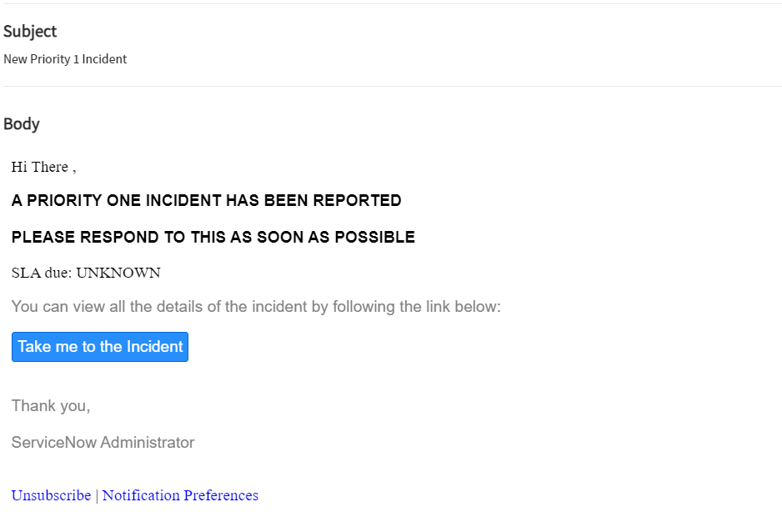

The Email Template must look similar to this.  
   
To do this :

1. Add Hi There to the start of the template
2. Create a new email script under the name “incident_priority_one,”
3. Change the font size and font to match the font used in the template.
4. Include the SLA due: ${sla_due}’
5. Add the email script incident_take_me_to_the_inciden
6. Add the note in bold ”Note: This Is A System Generated Email. Please Do Not Reply To This”

### 

### 4.7 SLA Breach Notification (To Manager)

This already exists under the name sla breached. We shall modify it to meet our requirements as follows.

#### 4.7.1 - Notification Properties

| **Label** | **Data Type** | **Value** | **Referenced** | **Table Reference** |
| --- | --- | --- | --- | --- |
| Name | String | Priority One Incident Notification | No | N/A |
| Table | Table Name | Incident | No | N/A |
| Category | Reference | Incident Communication Plan | Yes | sys_notification_category |
| Active | Checkbox | True | No | N/A |
| Send When | Dropdown | Event Is Fired | No | N/A |
| Event | Dropdown | sla.warning.breach | No | N/A |
| Updated | Checkbox | True | No | N/A |
| Condition | Conditional Dropdown | None | No | N/A |

#### 4.7.2 Configure Receiver And Content

| **Label** | **Data Type** | **Value** | **Referenced** | **Table Reference** |
| --- | --- | --- | --- | --- |
| Users | list | SLA Manager | Yes | sys_user |
| Groups | list | Empty | Yes | sys_groups |
| User/Groups in field | Field list | Task.Assigned to, Task.Assignment group | No | N/A |
| Subscribable | Checkbox | False | No | N/A |
| Email Template | Reference | Unsubscribe and Preferences | Yes | N/A |
| Omit Watermark | CheckBox | True | No | N/A |
| Subject | String | New Priority 1 Incident | No | N/A |

#### 4.7.3 The Email Template

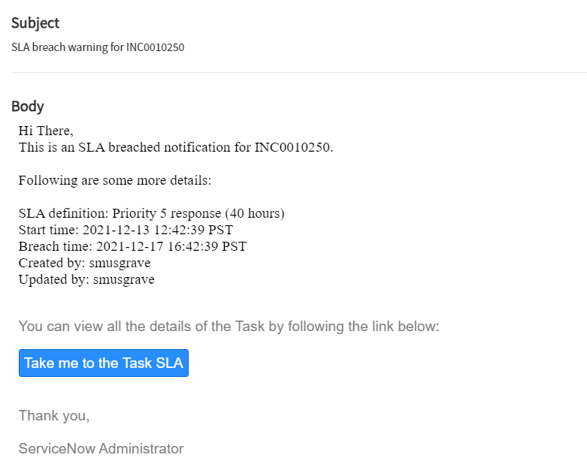

The Email Template must look similar to this.  
   
To do this :

1. Add Hi There to the start of the template
2. Add This is an SLA breached notification for ${task.number}.Change the font size and font to match the font used in the template.
3. Add the following details to be displayed

SLA definition: ${sla}

Start time: ${start_time}

Breach time: ${planned_end_time}

Created by: ${sys_created_by}

Updated by: ${sys_updated_by}

1. Create a new email script to display the button with the name “Take me to the Task sla”
2. Add the note in bold ”Note: This Is A System Generated Email. Please Do Not Reply To This”

## 

## 5.0 Conclusion

In conclusion, the OOB Incident application is full of inconsistencies which need to be remedied in order to make a sellable product. To accomplish this task, we’ve utilized our knowledge of scripts and policies to beautify the Incident forms. Once we’ve restructured the new forms, our attention then focuses on the notifications we will send to the user. By the end of this process, the Incident Application transitions from a boring, uninspiring, messy compilation of forms to a beautified and pleasing flow of modules.

- Assigned to back to read-only, auto-assign rule same as assignment group

- Remove irrelevant related links, SLA, etc

- Only assigned to person should be able to change fields(?)

- Assigned to should not disappear

- Should not be able to close an incident with tasks open